 I N V I T A T I O N
DEAR COLLEAGUES,
State University of Library Studies and Information Technologies (SULSIT) is organizing а two days Conference with international participation on “Digital Present and Digital Future: Economic, Cultural, Educational, Legal and Technological Impacts”, Sofia, Bulgaria, April 9-10, 2013.
On behalf of the Organizing Committee, keeping your expertise in view, you are invited to contribute a research paper of your interest.

ANNOUNCEMENT
&
CALL FOR PAPERS AND PRESENTATIONS

on

“Digital Present and Digital Future:
Economic, Cultural, Educational, Legal and Technological Impacts”
April 9-10, 2013, Sofia, Bulgaria

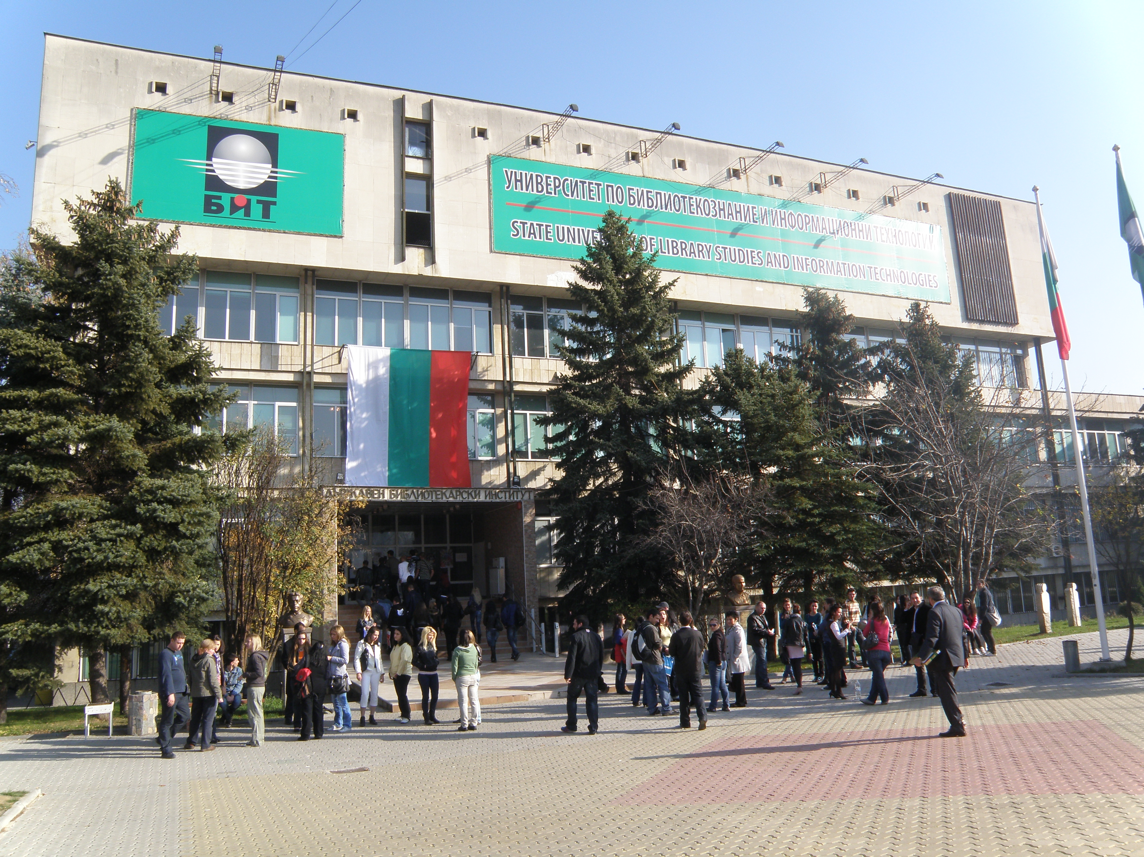
State University of Library Studies and Information Technologies, Sofia

Venue: Metropolitan Hotel Sofia
Sofia 1784, 64 Tsarigradsko chausse Blvd., http://www.metropolitanhotelsofia.com/
Organizing by: State University of Library Studies and Information Technologies (SULSIT)
Sponsors: This conference is being undertaken within the context of Project “Data base “Bulgarian Revival Towns” (CD), financed by Bulgarian Ministry of Education, Youth and Science, Scientific Project Funds (Annex 1/Д002/144/13.10.2011)

Further information: http://unibit.bg/

THEMES
Experts, academics, students and decision-makers are invited to share their research work and/or professional experience with regard to the economic, cultural, educational, legal and technological impacts of the Digital Present and Digital Future.
The deliberations will focus mainly on following areas. (However, any other relevant topic can be included/addressed as well):
1st Theme: Cultural and Educational opportunities of the Digital Present and Digital Future.
2nd Theme: Economic, legal and technological issues of the digital age.
3rd Theme: Studies for Bulgarian Revival Towns.
IMPORTANT DATES
- 25 February 2013: Submission of abstracts and author(s) short CV presentations to: aulcompetition@abv.bg or dr.tanya.todorova@gmail.com (see Abstract Submission Form)
- 1 March 2013: Notification of authors on papers’ acceptance
- 1 April 2013: Submission of final revised versions of papers for publication in the Conference Proceeding
- 3 April 2013: Submission of conference presentations in English (based on accepted papers).

TECHNICAL DETAILS
Deadline: 25 February 2013. English abstract (maximum ½ A4 page) and a short CV (200 words) presentation of the author(s).

Deadline: 1 April 2013. Submission of final revised versions of papers for publication in the Conference Proceeding.

Deadline: 3 April 2013. Submission of conference presentations in English – 20 slaids (based on accepted papers).

All papers should be submitted in English.
The overall length of a paper should not exceed 15 A4 pages (charts, notes, bibliography included), Times New Roman, 12 pt, without underline and additional design.
The paper should be accompanied by an English abstract (maximum ½ A4 page) and a short (200 words) presentation of the author(s).

Registration:
- Registration of Delegates & Authors starts from: January 10, 2013 (see Abstract Submission Form)

There is no Conference Fee. At least one author will be expected to attend conference to deliver the paper.
Important: Please note that the Organizing Committee has no funds to assist prospective authors. We do not cover any travel, accommodation and daily allowances expenses.

For accommodation assistance in Sofia you could contact to: Assoc. Prof. PhD Tania Todorova, Email: dr.tanya.todorova@gmail.com
Further questions about Submissions/Publication of Papers, Sponsorship, Publicity and Protocol you could address to: Assist. Prof. PhD Rumelina Vasileva (Email: rumivas@gmail.com) and Assoc. Prof. PhD Tania Todorova (Email: dr.tanya.todorova@gmail.com) - Department of Library Management, State University of Library Studies and Information Technologies, Sofia, Bulgaria

It is great pleasure for us to invite you to the Conference!

Yours sincerely,

Prof. DSc Stoyan Dentchev – Co-Chair of Organizing Committee and Rector of the State University of Library Studies and Information Technologies (SULSIT)

Prof. DSc Ivanka Yankova - Co-Chair of Organizing Committee, Dean of Faculty of Library Studies and Cultural Heritage and Project Manager

